AWS ECS Container Deployment- Stepwise Guide

Document status: First Final Draft
Created on: July 18, 2023
Last updated on: July 20, 2023
Contact: ITG Technical Writers, Bhavuk Mudgal

Contents
1 Overview 2
2 Business Scope 2
3 Audience 2
4 AWS ECS Container Deployment 2
4.1 Deployment Stages 2
4.2 Deployment Workflow 3
4.3 Deployment Steps 3
4.4 Developers’ Trigger Process for Production Pipeline in AWS Production Environment 16
4.4.1 Manual CodePipeline Trigger Process for Production Pipelines (ppsr & ipbulksearch) 16
5 Revisions 17
6 Document History 17
7 Document Control Log 17

Overview
This document presents step-by-step procedure reference for deploying container applications on AWS ECS (Elastic Container Service).

Business Scope
This guide outlines the need for a standardized AWS ECS deployment process for container applications, ensuring adherence to detailed steps and minimizing provisioning discrepancies.

Audience
The technical document is intended for the Infrastructure and Business Teams.

AWS ECS Container Deployment
The section provides a sequential reference to deploying container applications on AWS ECS, covering deployment stages, workflow, deployment steps, and steps for triggering production pipelines in the AWS Production Environment.

Deployment Stages
The general workflow of deploying a container application in AWS includes these ten stages:

Stage 1: Write Dockerfile on the local development server in AWS Dev, e.g., AWSDLINNLPGUI and AWSDLINNLPGUI2.

Stage 2: Build the first Docker image on the same server.

Stage 3: Build the first container from the built image in Stage 2 and evaluate its functionality.

Stage 4: (a) If the container runs successfully, push the built Docker image to AWS ECR in the Dev account, creating a new AWS ECR Repository (also called a registry).

(b) If the container does not run, repeat stages 1-3 until a successful container runs on the local development server.

Stage 5: Scan the newly pushed Docker image in AWS ECR using the Docker Container Tenable scanner hosted on AWSLINTENABLEDEV in Dev, and view results on the Tenable UI.

Stage 6: Remediate all detected security vulnerabilities to achieve a Docker image with ZERO vulnerabilities.

Stage 7: Create the first AWS ECS container.

Stage 8: If the AWS ECS container ran successfully, set up internal (Infoblox) and external (route53) DNS records and generate SSL certificates for secure HTTPS.

Stage 9: Create CI/CD Pipelines for available environments: Stage, UAT, and Production.

Stage 10: Thoroughly test and validate the CI/CD Pipelines to ensure smooth application deployment.

Deployment Workflow
The diagram illustrates the high-level workflow for developers to deploy AWS ECS container applications:
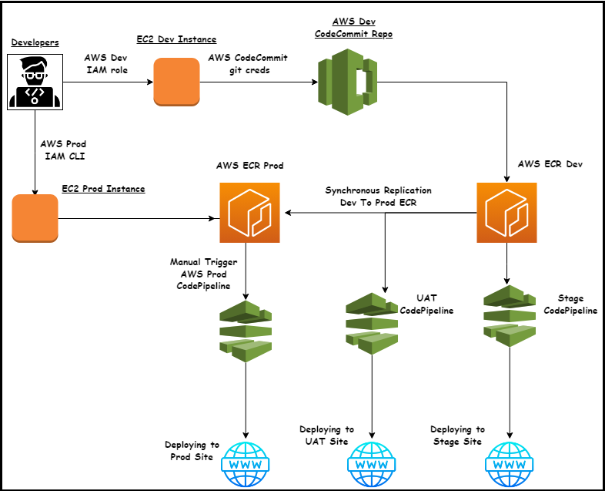

Deployment Steps
Developers must follow these steps to deploy container applications in AWS ECS:
Step 1 Log in to the AWS Dev Management console via Okta:
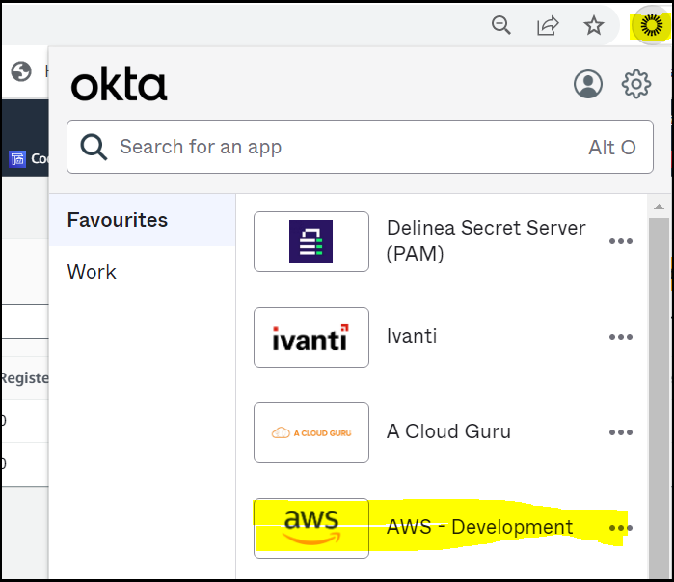
Step 2 Navigate to ECS:
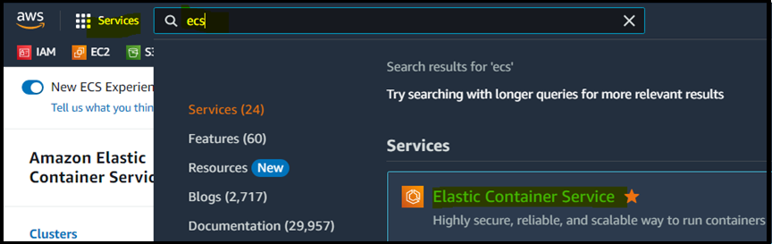
Step 3 Create a new ECS cluster or use an existing one:
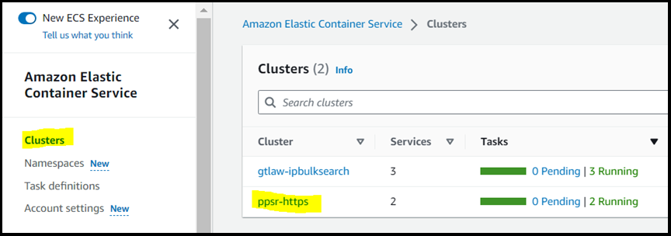
Step 4 Create a task definition for the application:
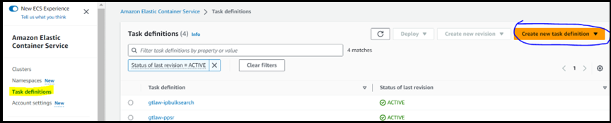
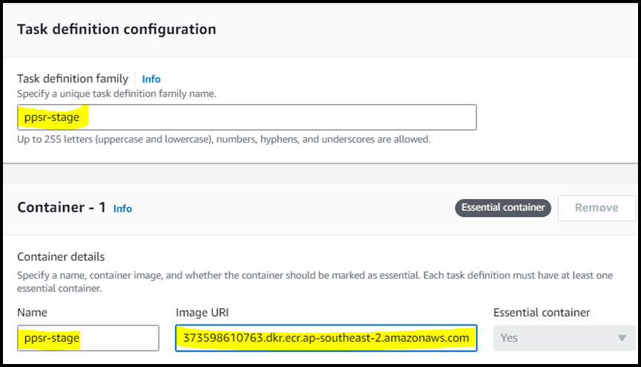

Step 5 Copy the image URI from the ECR dashboard, keep port mappings and other information as follows, and click Next:
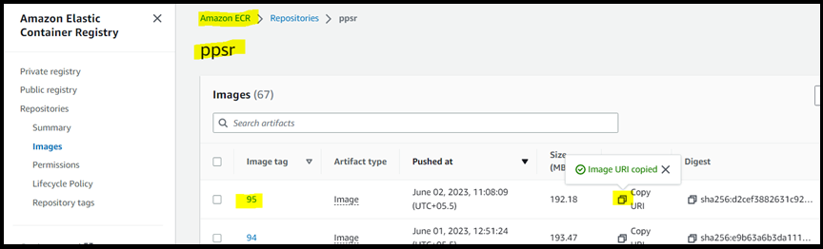
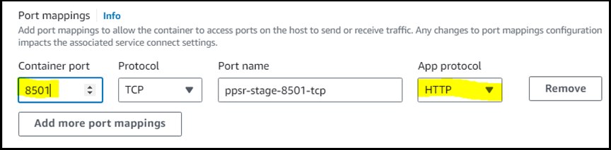
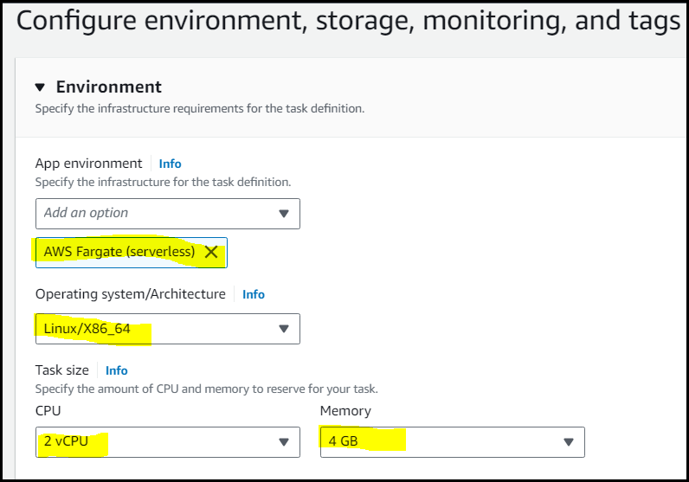
Step 6 Add mandatory tags (as highlighted) and click Next:
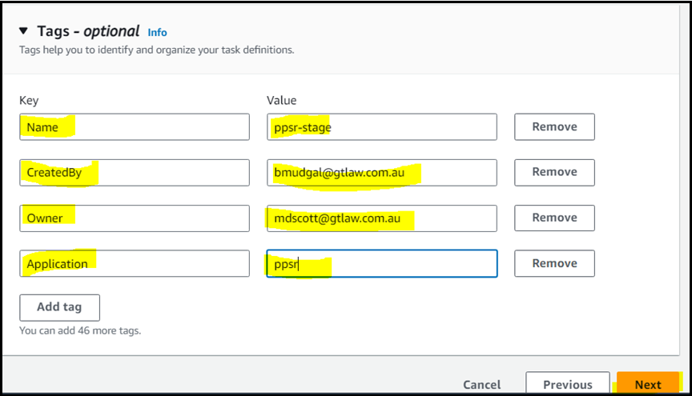
Step 7 Review the information and click Create:

Step 8 Create a Service within the newly generated task definition:
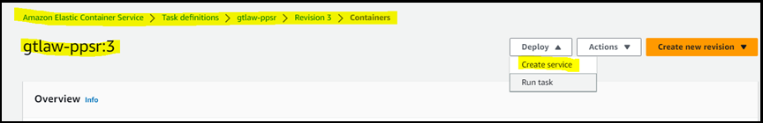
While creating a ppsr service, ensure to keep the required information and settings as illustrated in the screenshots below:
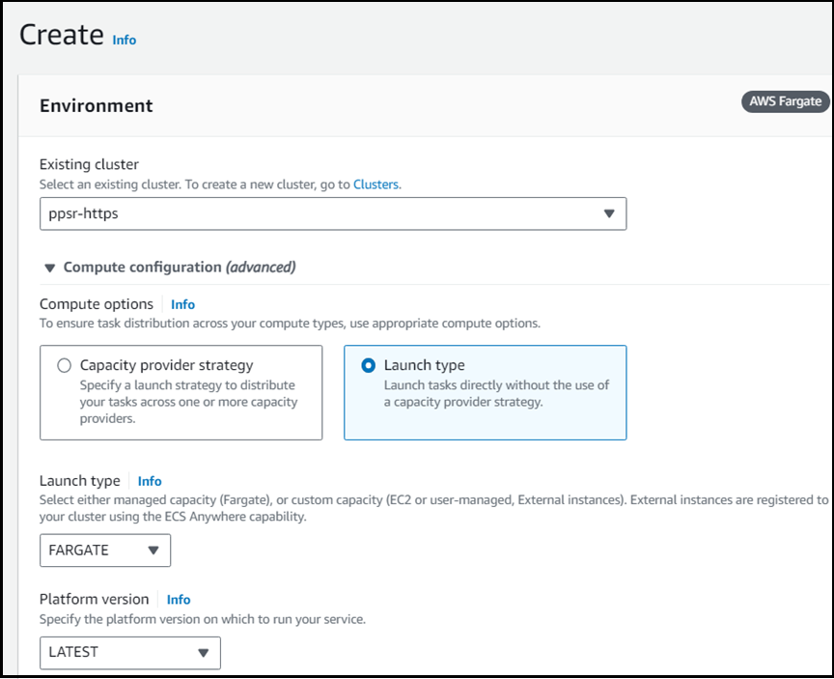
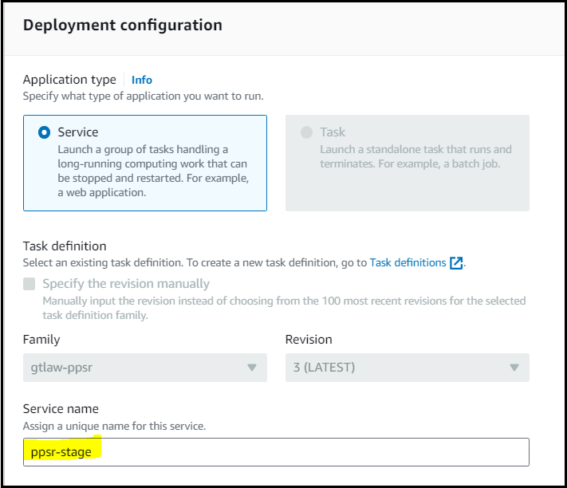
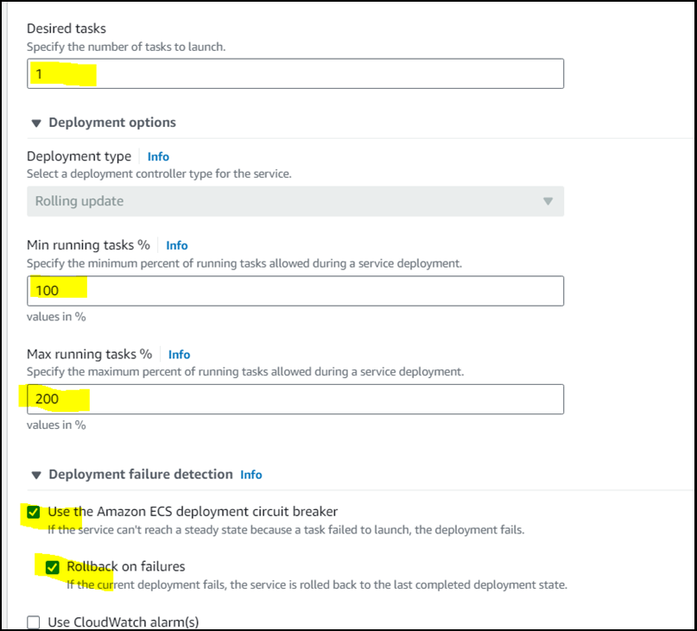
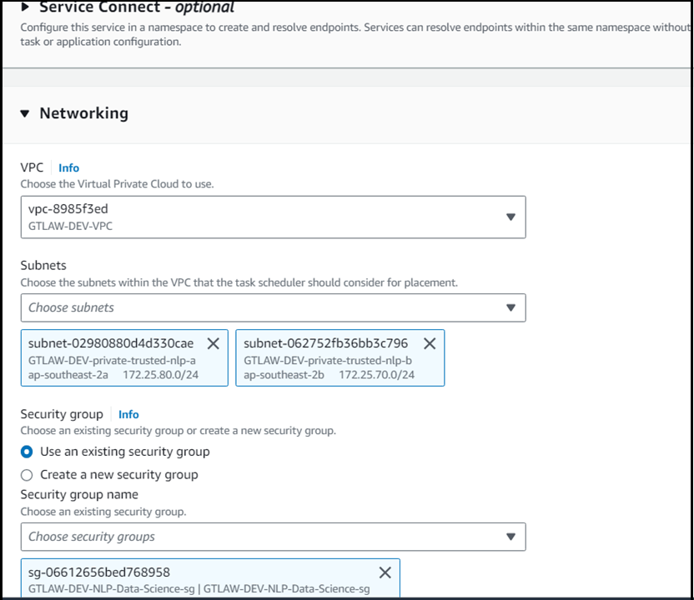
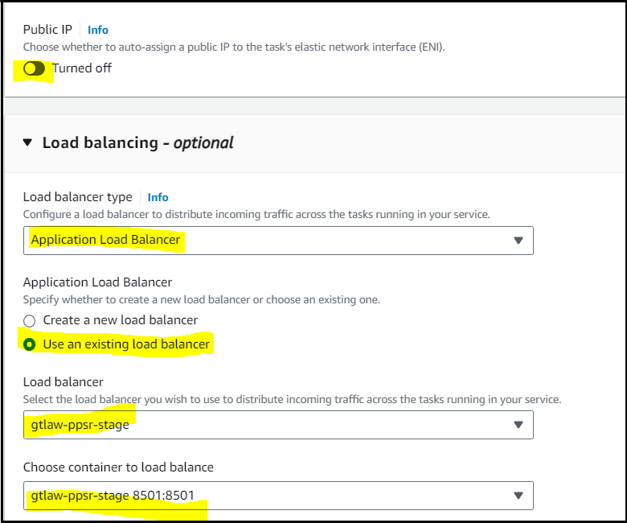
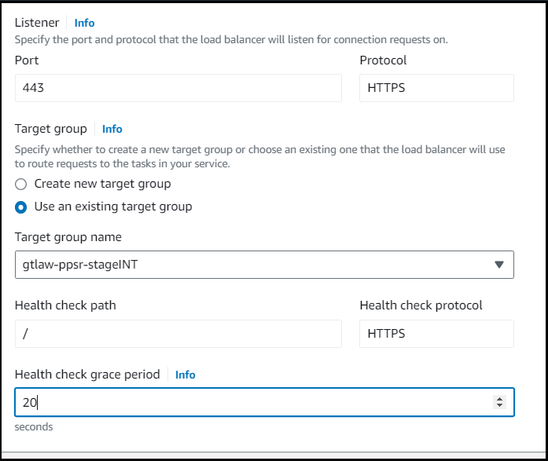

Step 9 Click Create and review the service status:
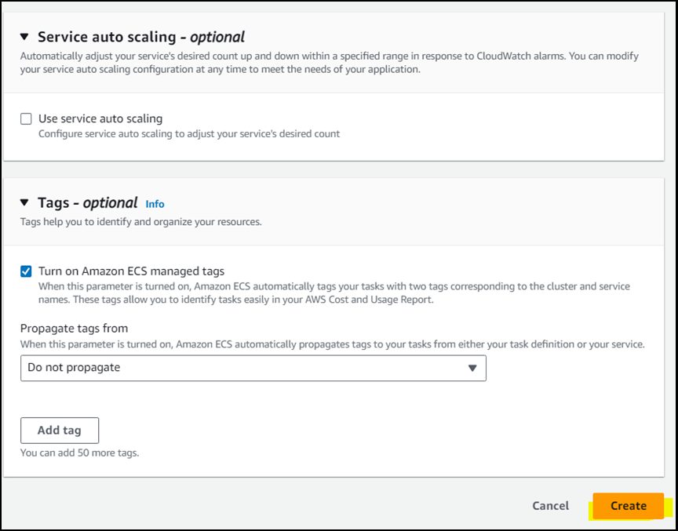
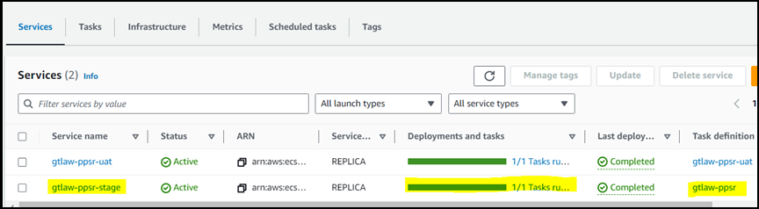
Step 10 Access the application using the task’s IP address:
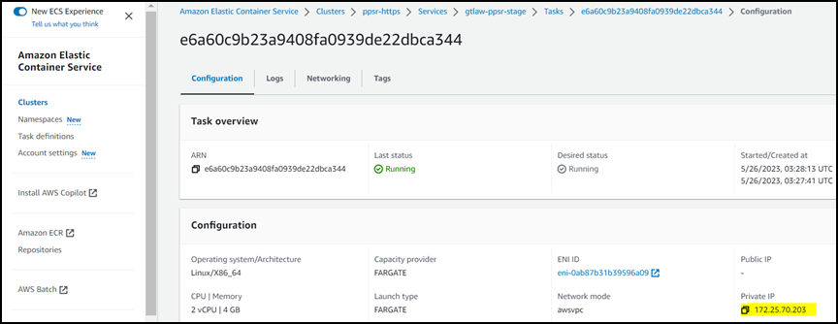

Step 11 Navigate to the CodePipeline service to deploy the pipeline:
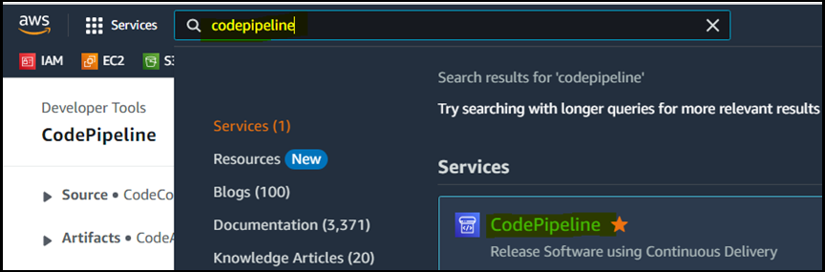
Step 12 Click Create Pipeline:
Step 13 Configure pipeline settings as described and proceed:
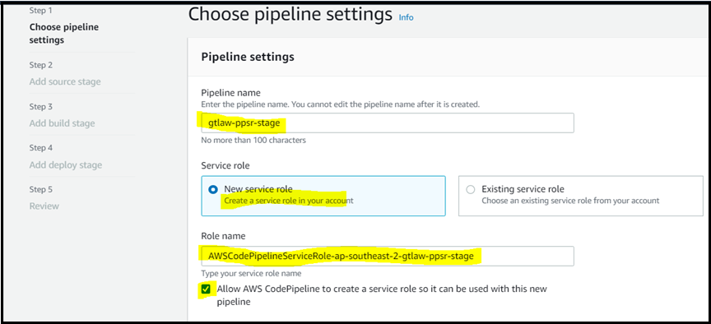
Step 14 Mention the source info described and proceed:
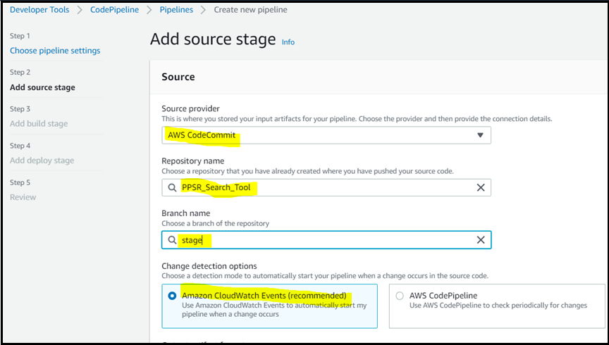

Step 15 Create a new code build project as illustrated in the screenshots below:
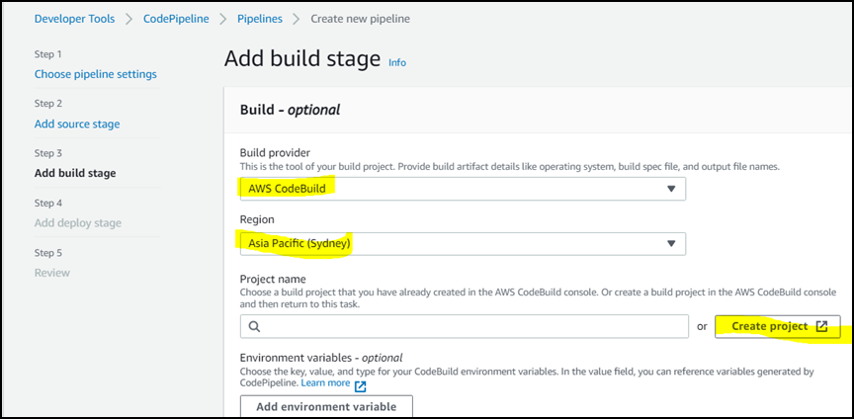
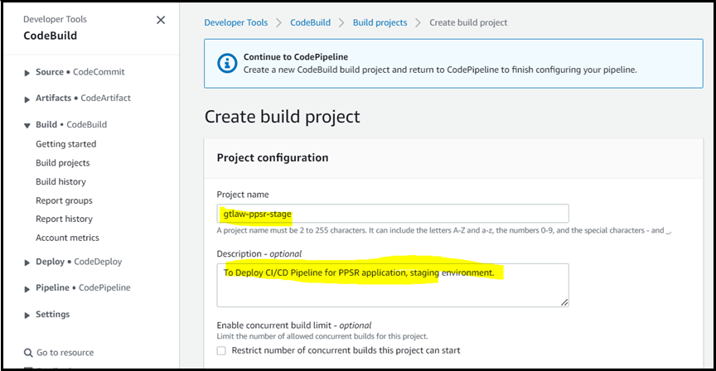
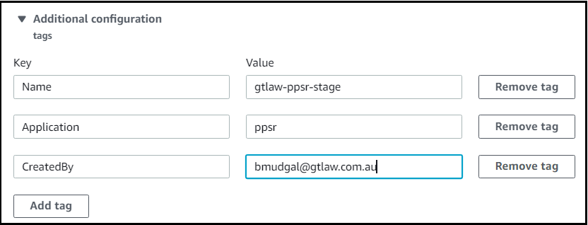
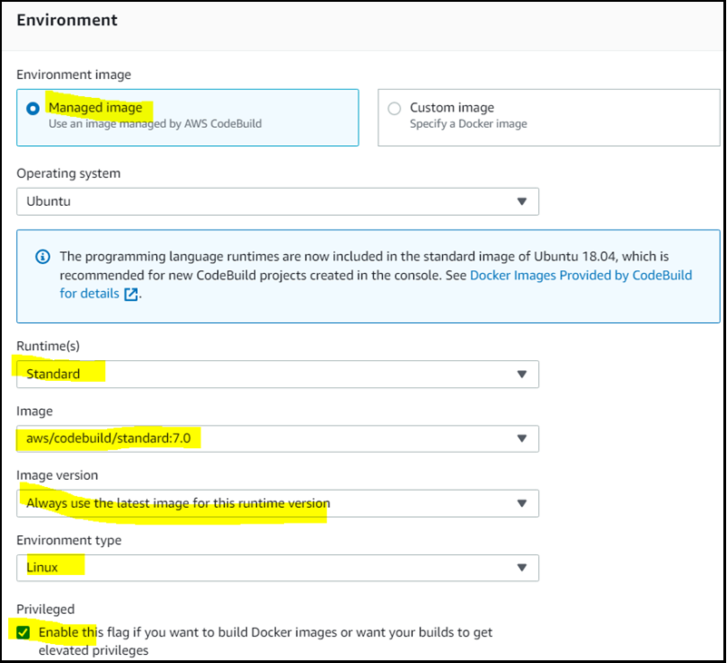
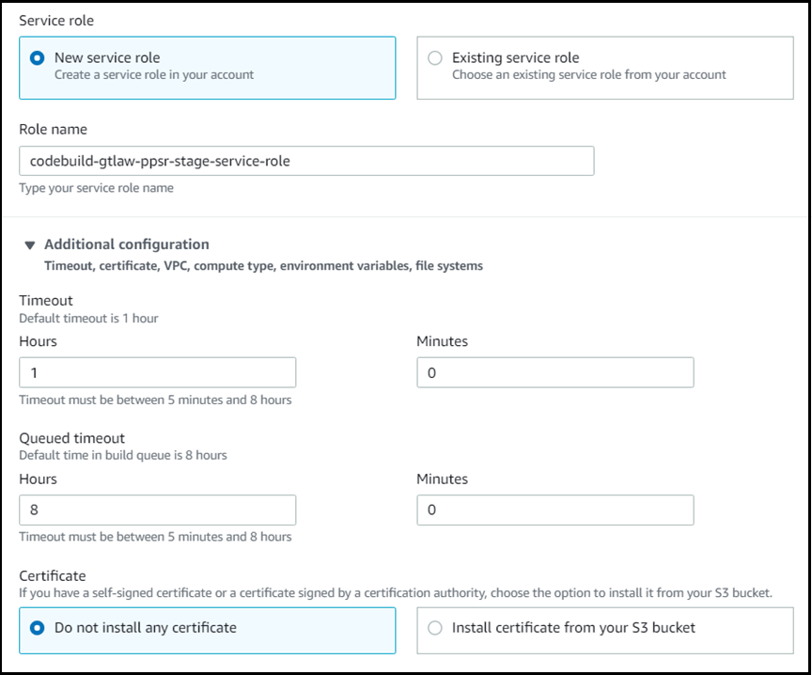
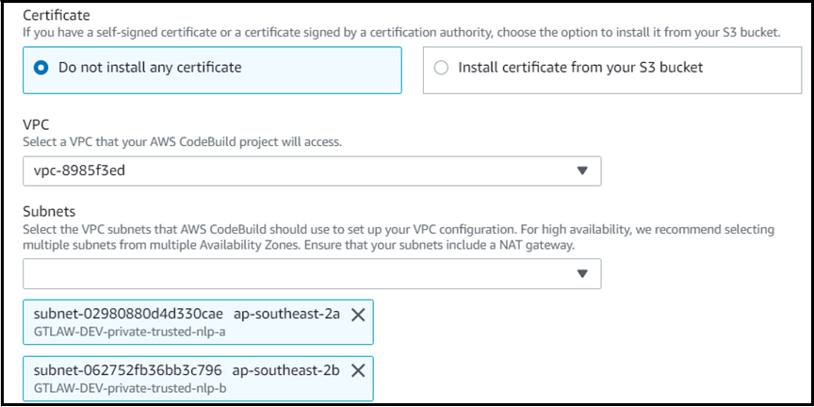
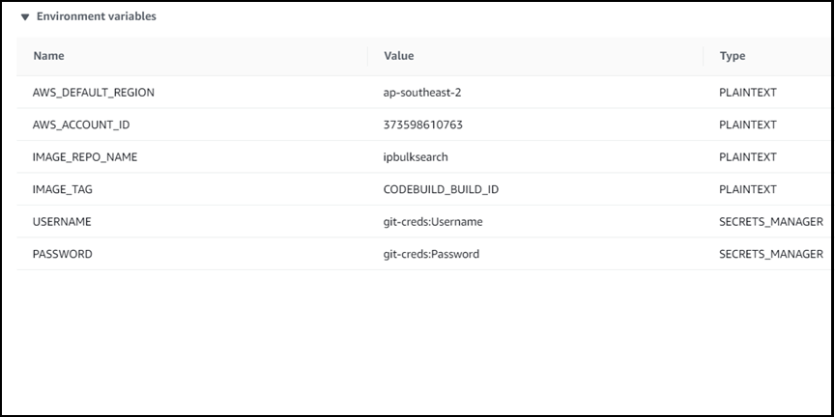
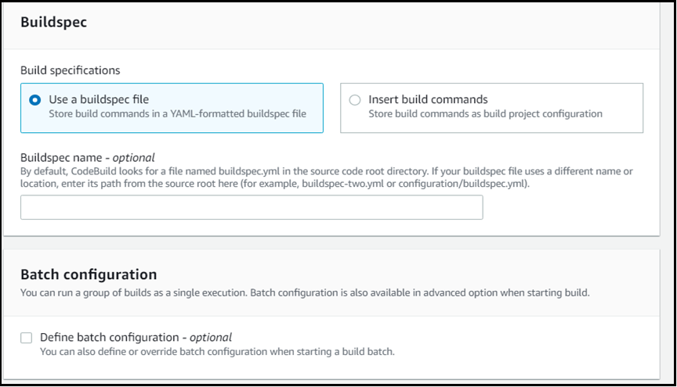

Step 16 Click Continue to CodePipeline to see the Code Pipeline dashboard, and then click Next until you reach Step 4: Add deploy stage:
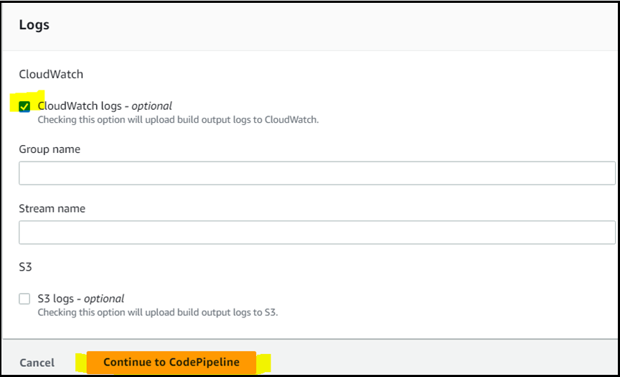
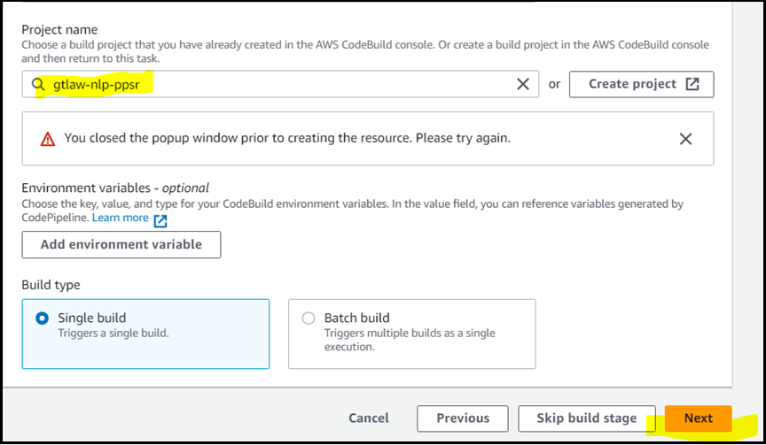
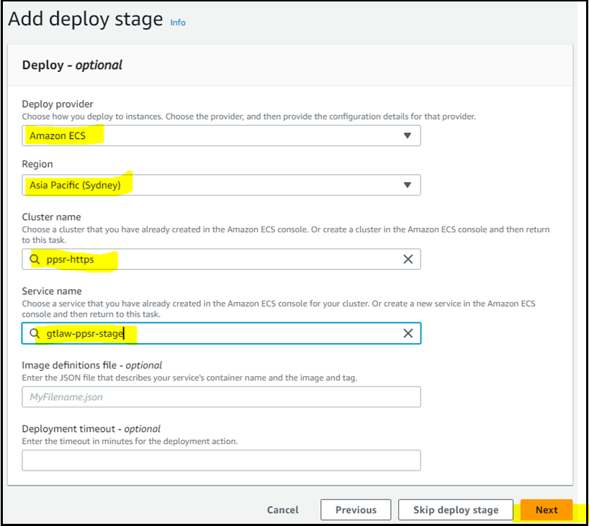
Step 17 Review deployment details and click Create pipeline:
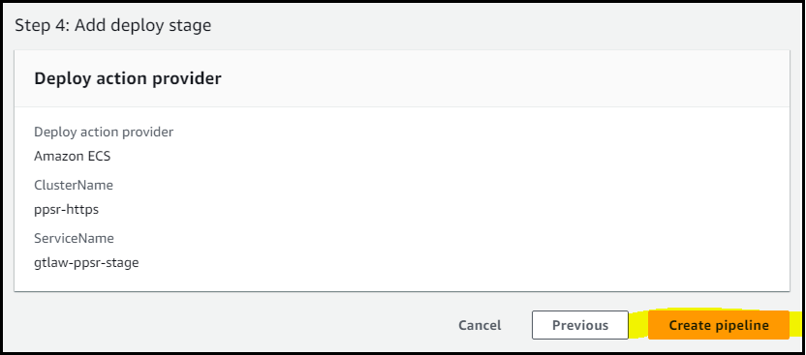
To test the “Stage” pipeline, ask the developer to push a sample change to the staging branch of the CodeCommit repo, which should trigger the pipeline and deploy the new code on the site.
Step 18 On the internal AWS load balancer, configure the Listeners, as illustrated below:
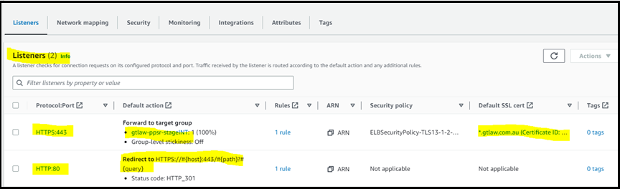
Monitor the Load Balancer target groups as follows:
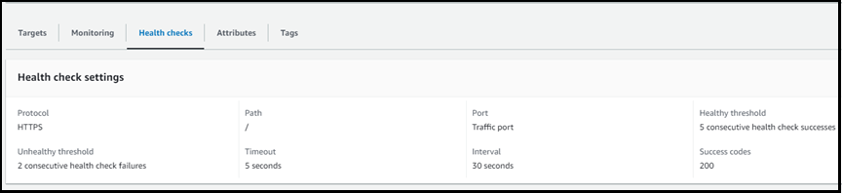
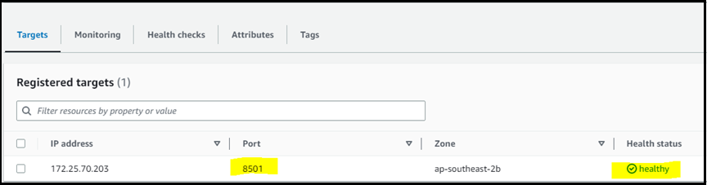
Step 19 Create a DNS entry in Infoblox to point the Internal Load Balancer CNAME to an FQDN (example: env.app.gtlaw.com.au).

Developers’ Trigger Process for Production Pipeline in AWS Production Environment
After verifying the UAT image for deployment in Prod, developers manually trigger production pipelines.

Manual CodePipeline Trigger Process for Production Pipelines (ppsr & ipbulksearch)
- Verify the latest AWS ECR Docker image for UAT and log in to the Dev Instance.

- SSH to the prod instance from your dev instance, run: sshprod.

- Remove the "latest" tag from the image in AWS ECR in Prod (run: ppsruntagimg for ppsr, ipuntagimg for ipbulksearch).

- Copy the latest ECR Prod image 'Digest' (run: ppsrlatimg for ppsr, ipuntagimg for ipbulksearch). Hit the spacebar until you reach the end of the page to get the latest image details.
- Update the bash script to tag the latest image with 'latest' tag (vim ppsrtag.sh for ppsr, vim iptag.sh for ipbulksearch). Replace the existing digest with the one you copied. Save & quit.
- Apply the 'latest' tag by running the bash script (./ppsrtag.sh for ppsr, ./iptag.sh for ipbulksearch). It will only work in your home directory.
- Check pipeline status (run: ppsrstatus for ppsr, ipstatus for ipbulksearch).

- For ppsr, if you do not see any 'InProgress" pipeline execution ID, run: ppsrstart.
- Check again for the "InProgress" execution ID, run: ppsrstatus.
- Check the execution ID at the top, which is the latest one. When the pipeline finishes successfully, you will see the "status" as "Succeeded."
Please note that the steps above might vary for different applications.

Revisions
The Infrastructure, Business Systems, and Technical Writing teams review, test, and revise this document as risks, systems, and business practices change.

Document History
Title | AWS ECS Container Deployment- Technical Document
Version | 0.1
Classification | Internal, Infrastructure
Creation Date | July 18, 2023
Last Review Date | July 20, 2023
Author | Priya Bhatia
Custodian | Infrastructure Team
Document Number

Document Control Log
Version | Change Description | Created by | Reviewed/Approved by | Date of Creation
0.1 | Created the first final draft | Priya Bhatia | Vikram Yadav, Bhavuk Mudgal | July 18, 2023

